WP1 Tachymeter P-controller

1. Description of the sensor
2. This part should contain the **name**, **function**, **characteristics/pros and cons** of the sensor
3. The figure and equations could be attached if possible.
4. Font and font size, numbering and typesetting should follow given format.
5. Description of the controller

The same requirements as before.

1. Evaluation
2. This part might contain:

* Figure and chart
* Analysis and compare
* Problem and possible reasons, as well as the solution

1. Appendix

Source code (no need be added into report, just hand in the **m-file** would be fine)

1. Example of format

$V\left(r,λ,θ\right)=\frac{GM}{R}\sum_{l=0}^{L}{{\left(\frac{R}{r}\right)}^{l+1}\sum_{m=0}^{l}{{\overline{c}}_{lm}{{\overline{Y}}^{c}}_{lm}\left(θ,λ\right)+{\overline{s}}_{lm}{{\overline{Y}}^{s}}_{lm}\left(θ,λ\right)}} (example)$ (1)

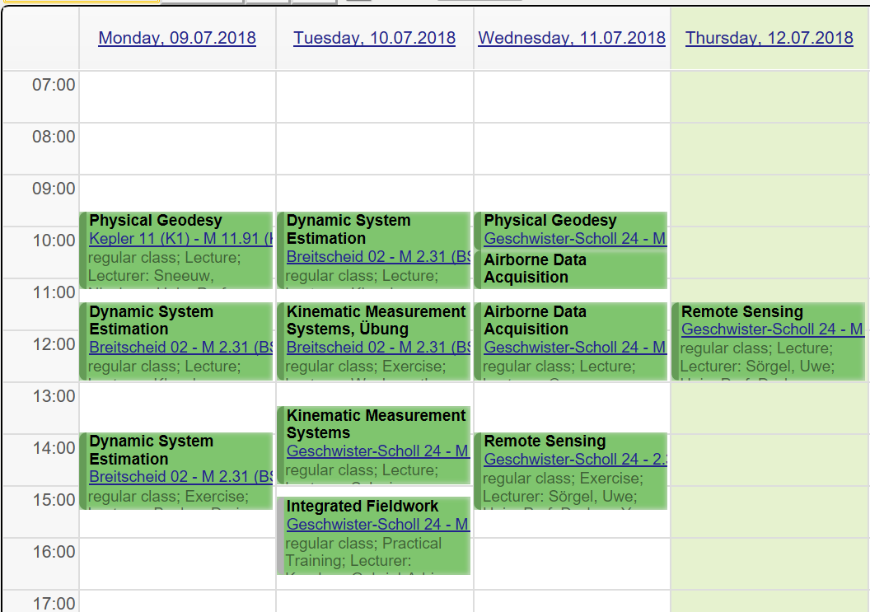

Figure 1 Lecture calendar of Geoengine (example)

Table 1 Compare of standard deviation between check points and terrain points (example)

|  |  |  |
| --- | --- | --- |
|  | Check points[mm] | Terrain points[mm] |
| x | 0.0141 | 0.011 |
| y | 0.0150 | 0.009 |
| z | 0.0278 | 0.038 |